INTERN / STUDENT FIREFIGHTER VACANCY

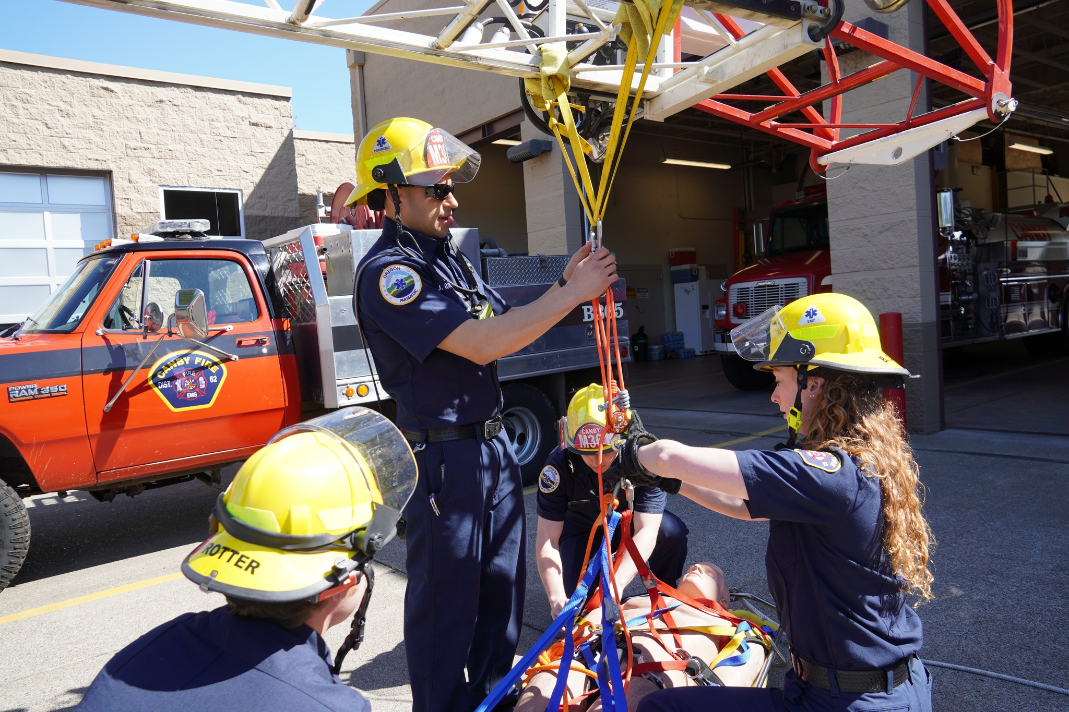
Canby Fire District is seeking applicants to fill five (5) positions in the District’s Intern / Student program. This is an opportunity to gain experience for those individuals who are pursuing an education leading toward a fire service / emergency medical career. Canby Fire District’s Intern Program has been very successful in placing people in career firefighter and EMS positions. Applicants must possess a valid Oregon Driver’s License, pass a background check, have their EMT License and/or be enrolled at a community college in a EMT, EMTP or Fire Science program.

Canby Fire responds to over 3,500 emergency calls per year. The area covers approximately 54 square miles, including the City of Canby, City of Barlow, and an ASA to the east portion of the district. Canby provides automatic aid to all our county partners as well as TVF&R. Canby Fire has three (3) immediate openings for Resident Interns at Station 365 on Highway 170. Students living at the station receive free housing in exchange for maintaining the station. All Interns are assigned to a shift at Station 361 or Station 363 and are expected to participate with the 24-hour shift when not in school. Tuition and books are reimbursed by the district for approved classes.
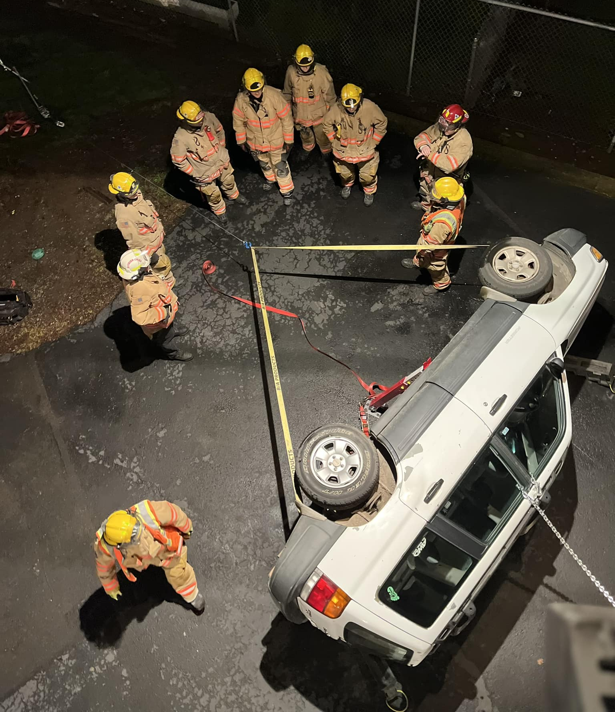
Application packets describing the position in full will be available at Canby Fire District Station 361, located at 221 S. Pine St., Canby between the hours of 9:00 a.m. to 3:00 p.m., Monday through Friday, or online at www.canbyfire.org/volunteer-opportunities. Please call (503) 266-5851 with questions or stop by to talk with our personnel.

Applications will be accepted August 24, 2023 until positions are filled. Drop off completed applications at Station 361 or email them to jdavis@canbyfire.org.

